My Grandma

My Grandpa

My Aunt Chunxia

My sister Qianqian

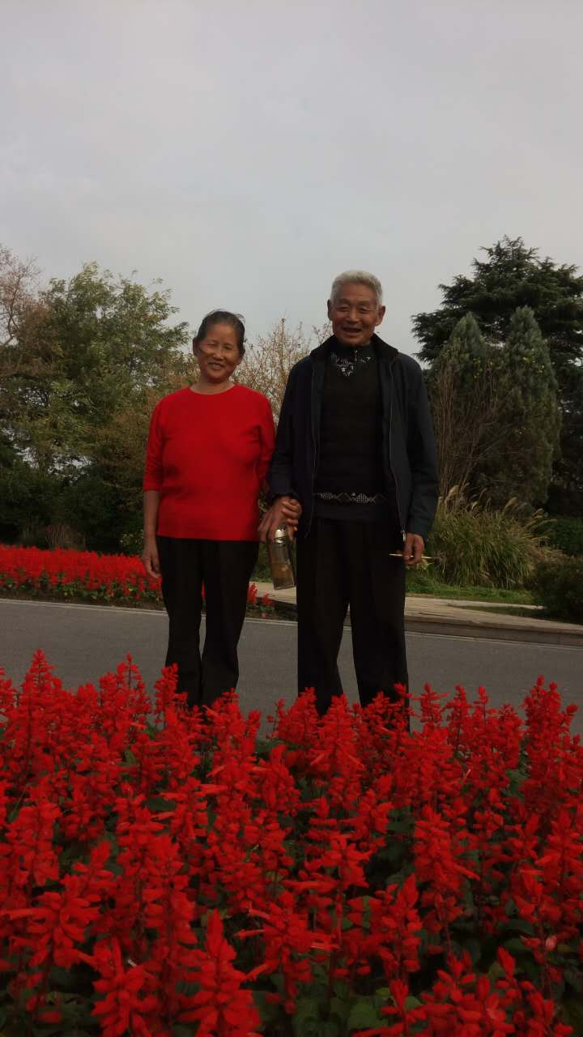

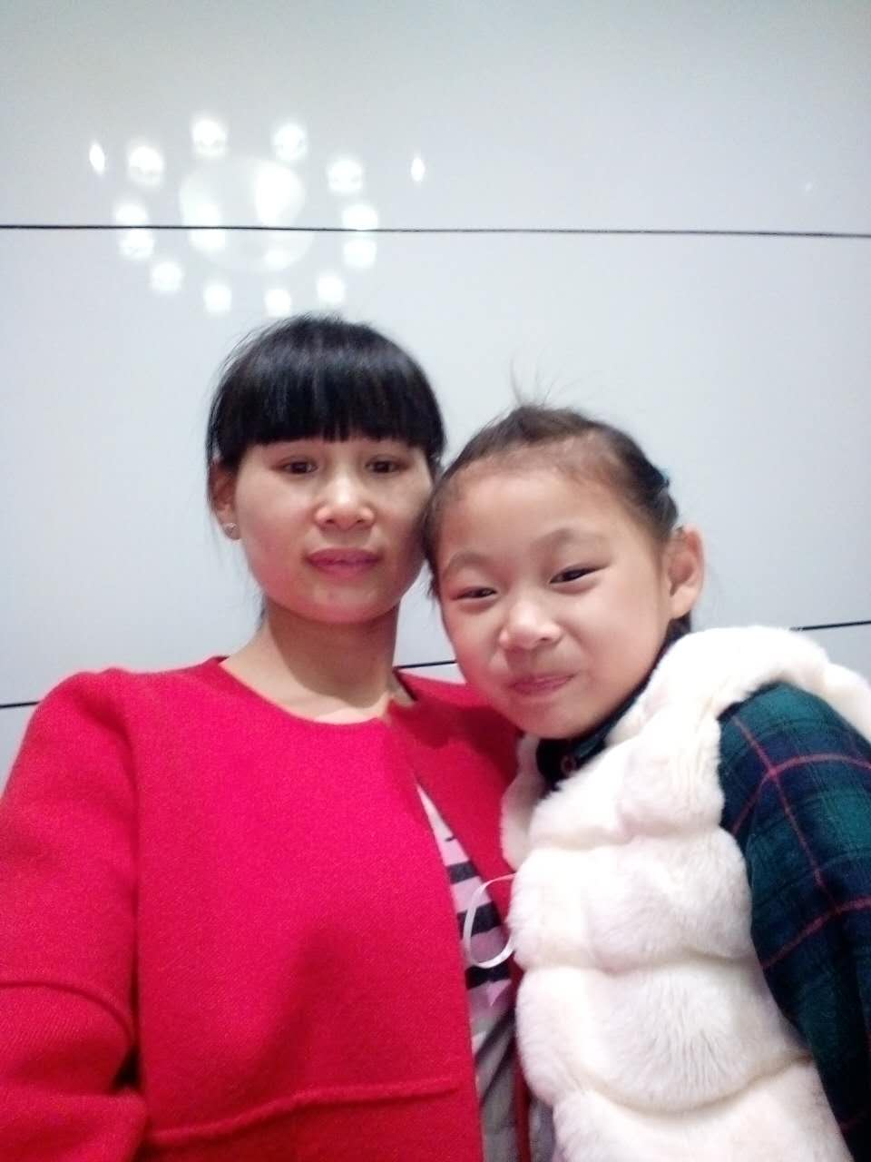

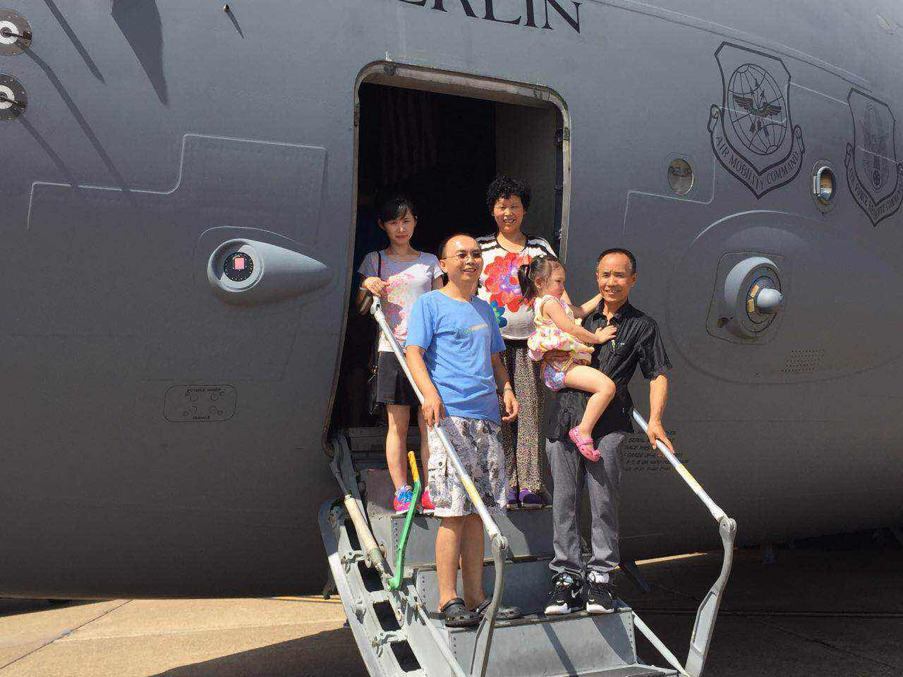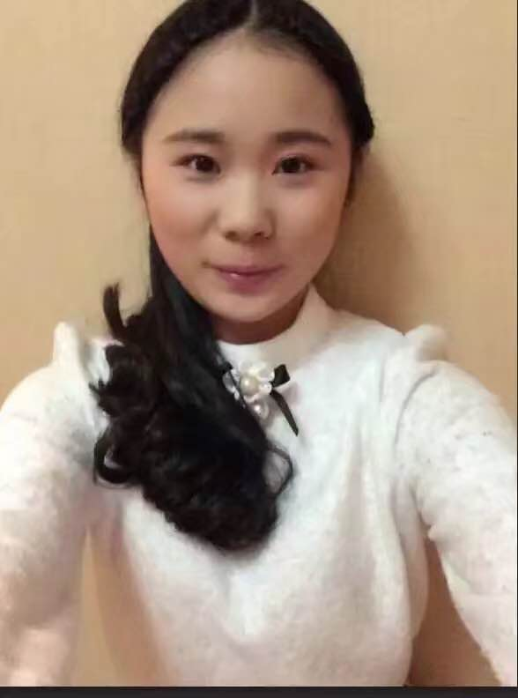

Grandpa, Grandma, Dad, Mom and Silvia

At Arkansas Air-force Expo

My Sister Xin Zhang

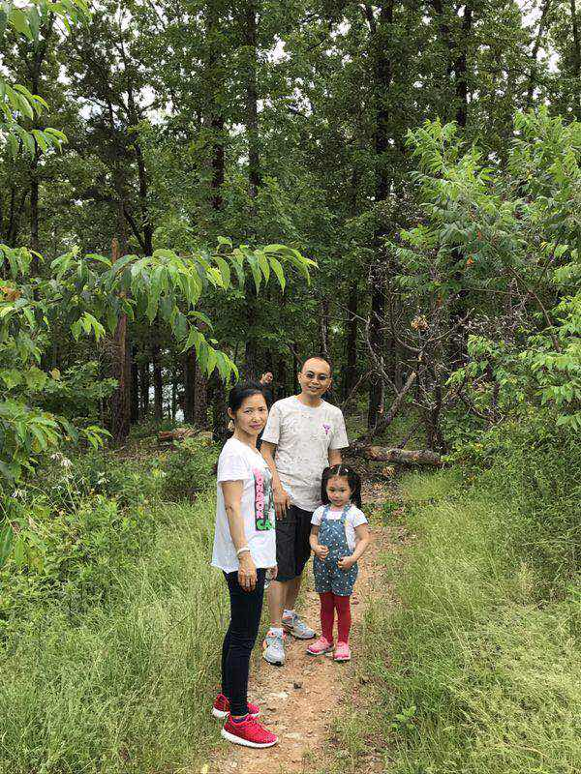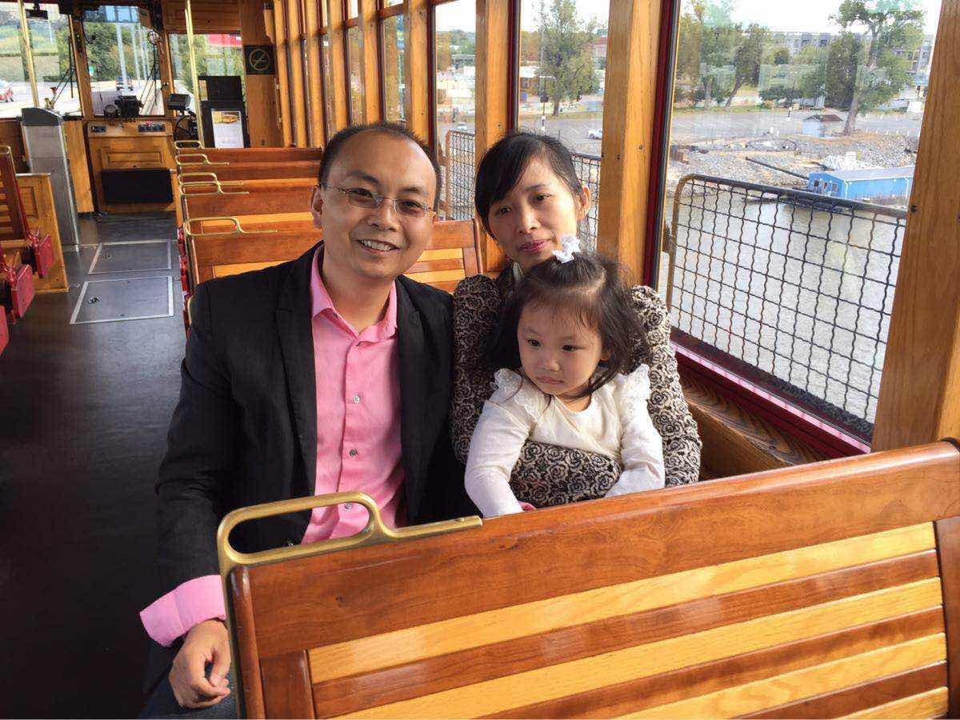

My Dad, Mom and Silvia

At Lake Ouachita

My Dad, Mom and Silvia

At Little Rock tour train

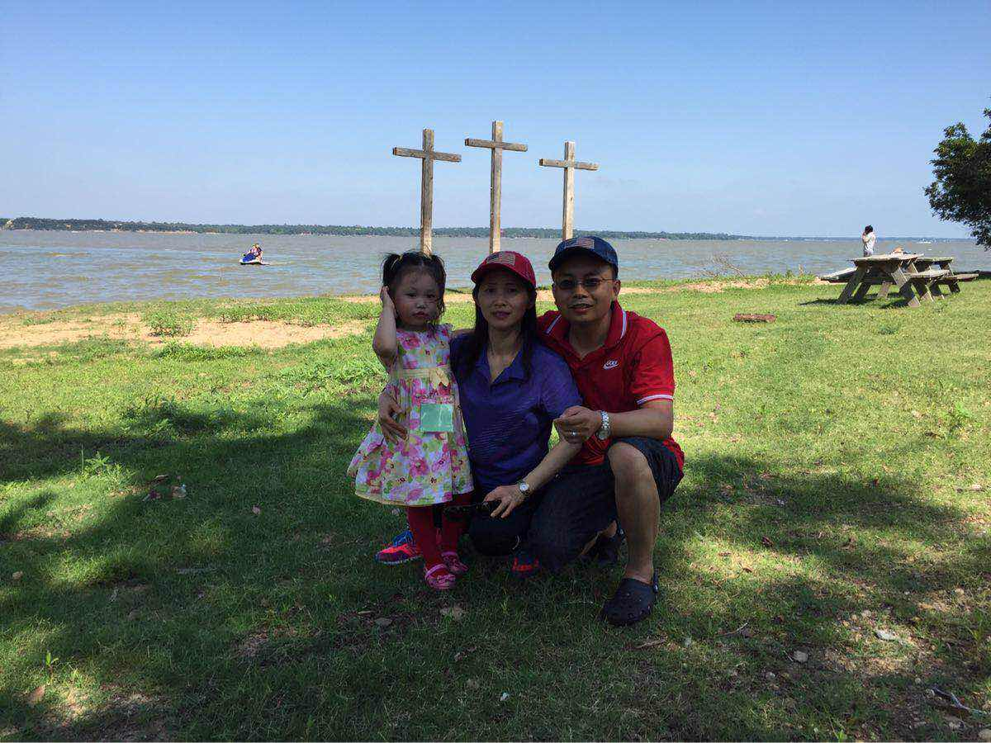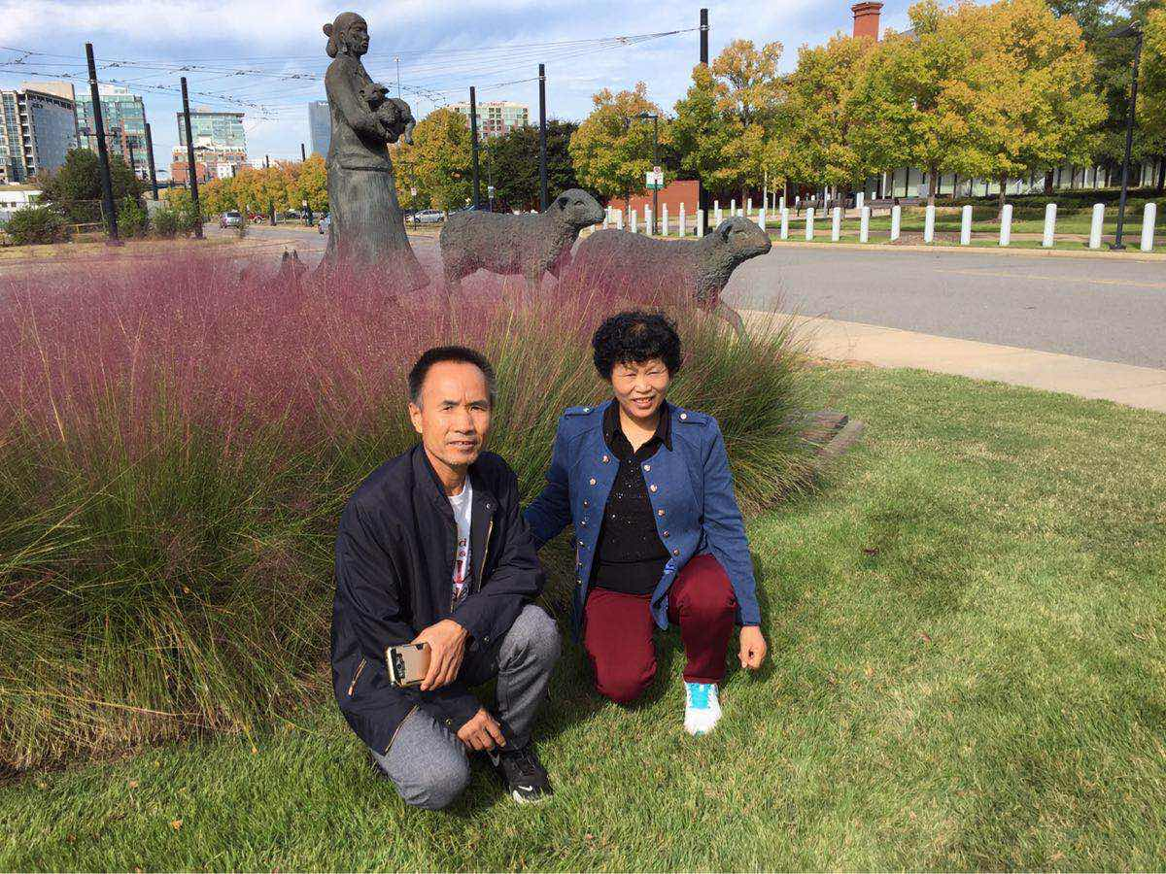

My Dad, Mom

At White Lake TX

My Grandpa, Grandma

At William J Clinton Library

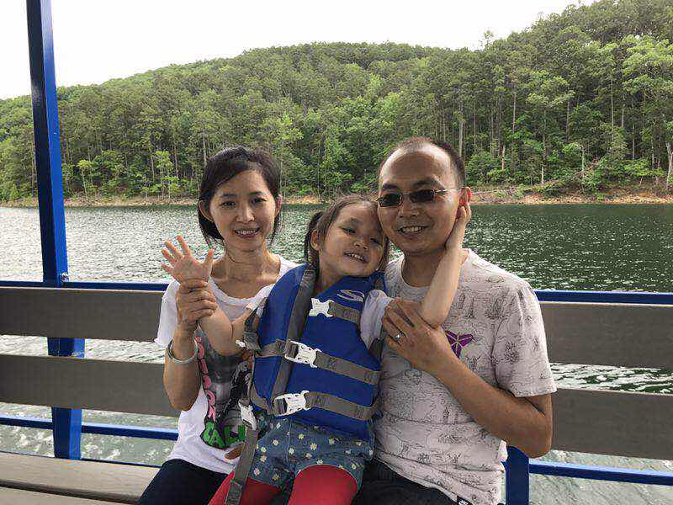

Dad, Mom, Silvia

At Lake Ouachita

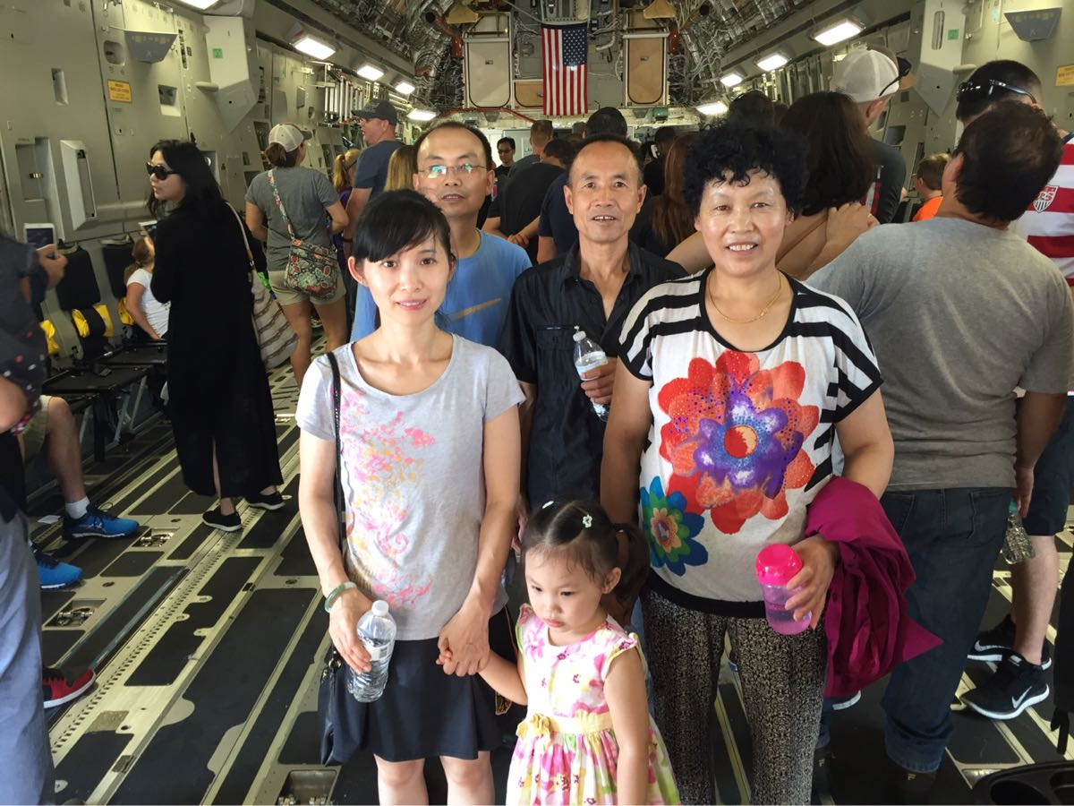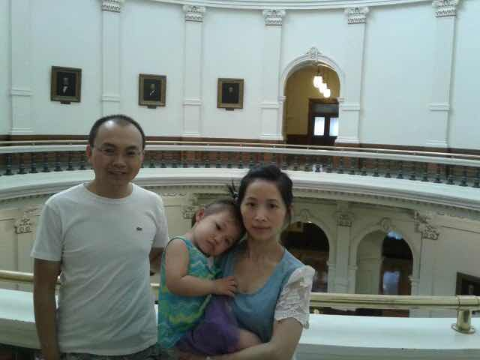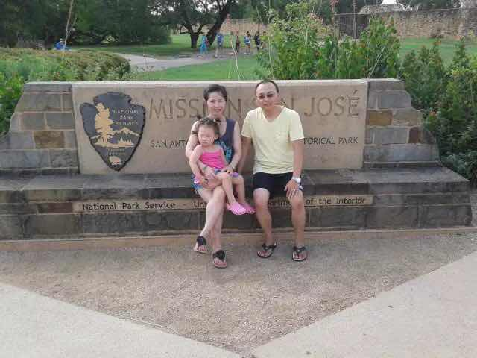

Grandpa, Grandma, Dad, Mom and Silvia

At Arkansas Air-force Expo

Dad, Mom, Silvia

At Texas State Capitol

Dad, Mom, Silvia

At Mission San Jose San Antonio